CENTRIFUGATION

1.1 Fundamentals and Definitions
A centrifuge comprises....
- Electric motor
- Drive shaft
- Rotor to hold tubes
SEDIMENTATION of suspended and some dissolved particles occurs due to centrifugal force.
Two principal uses
- Separate out solid matter as a PELLET from dissolved solutes as SUPERNATANT
- Separate soluble macromolecules of different mass or density
Also sometimes used to provide centrifugal force to drive other processes, eg ultrafiltration.

1.2 Centrifuge Rotors
A. Fixed Angle Rotor
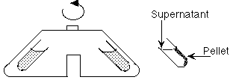
Advantage: | Sedimenting particles have only short  distance to travel before pelleting.  Shorter run time.  The most widely used rotor type.
B. Swinging Bucket Rotor
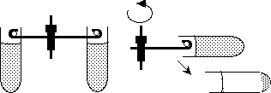
Advantage: | Longer distance of travel may allow better separation  eg in density gradient centrifugation.  Easier to withdraw supernatant without disturbing pellet.

1.3 Principles of Centrifugation
Sedimenting force on particle
= Mass x centrifugal field
= mω²r
where ω = angular velocity of rotor (radians/sec)
r = radius (ie distance of particle from axis of rotation)
Relative Centrifugal Force (RCF)
RCF = 1.119 x 10⁻⁵ x (rpm)² x r
RCF value reported as "No. x g" (ie multiples of earth's gravitational (force).
Equation used to calculate NOMOGRAMS (see eg Holme & Peck p 147) for quickly finding RCF at given speed and rotor type (radius).

1.3.1 Interacting Forces in Centrifugation
Sedimenting force, mω²r, is opposed by...
- Flotation Force (Archimedes)
= mω²rvρ
where: v = partial specific volume
(volume displaced by 1g of sedimenting particles)
ρ = density of solution
NET SEDIMENTING FORCE on particle, after allowing for flotation
= mω²r(1- vρ)
- Frictional Resistance
against particle moving through fluid.
= f.v
where: f = frictional coefficient
v = particle velocity
- Diffusion
- acting to counter uneven concentration distributions set up when dissolved molecules sediment.
BALANCE between the
SEDIMENTING FORCE and
COUNTERACTING FORCES
leads to various formulae and equations used in
- PREPARATIVE CENTRIFUGATION
eg to calculate the time required to sediment a particle to the bottom of the tube
and in
- ANALYTICAL ULTRACENTRIFUGATION
techniques used to determine SEDIMENTATION COEFFICIENTS and MOLECULAR MASSES of dissolved macromolecules.

1.4 Density Gradient Centrifugation
In absence of a density gradient, separated bands of solute in the centrifuge are gravitationally unstable.
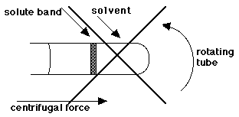
CAN'T OCCUR because layer of concentrated, dense solution overlaying less dense solvent would lead to mixing by convection and nullify the separation.
In absence of stabilising density gradient, can form boundaries (cf electrophoresis 9.3) but not zones. In analytical ultracentrifuge, moving boundaries and concentration distributions observed by optical device.
Create DENSITY GRADIENT in tube
Use a non-interacting, low M.Wt solute in continuously increasing concentration from meniscus to bottom of tube.
Important technique for purifying proteins and particularly nucleic acids.
Two different types of density gradient centrifugation, for two different purposes are:
- Zonal (or Rate Zonal) Centrifugation
(Sucrose density gradient centrifugation)
- Isopycnic Centrifugation
(Caesium chloride density gradient centrifugation)

1.4.1 Zonal Centrifugation
Mixture to be separated is layered on top of a
SUCROSE, or FICOLL, GRADIENT
(increasing concentration down the tube)
- provides gravitational stability as different species move down tube at different rates forming separate bands.
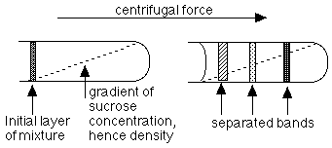
Species are separated by differences in SEDIMENTATION COEFFICIENT (S)
= | Rate of movement down tube
= | Centrifugal force
S is increased for particle of LARGER MASS
(because sedimenting force α M(1-vρ)
S is also increased for MORE COMPACT STRUCTURES of equal particle mass (frictional coefficient is less)
Mild, non-denaturing procedure, useful for protein purification, and for intact cells and organelles.

1.4.2 Isopyncic Centrifugation
Molecules separated on EQUILIBRIUM POSITION, NOT by RATES of sedimentation.
Each molecule floats or sinks to position where density equals density of CsCl solution. Then no net sedimenting force on molecules.
Isopycnic = Equal density
and separation is on basis of DIFFERENT DENSITIES of the particles.
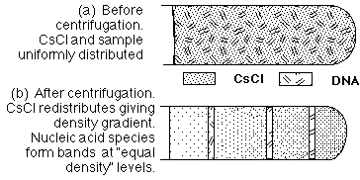
Very useful for purifying nucleic acid species of different density; also in separating proteoglycans extracted from cartilage.
Density gradients are used in many different operations:
- To separate particles of different densities (isopycnography, which is short for "equilibrium density gradient centrifuation)
- To separate particles of different sizes (sedimentation centrifugation)
- Column elutions that must smoothly go from one concentration to another
- Isolation of diamond dust (isopycnography)
- Isolation of bovine X-sperm from Y-sperm (dairy industry) (sedimentation without centrifugation)
There are several ways for making density gradients including those that use syringes, twin linked containers, and other devices. Here are two very simple additional ways to make linear density gradients:
- This might be simple but it is one that takes many hours: fill a plastic centrifuge tube with - say - a 10% sucrose solution. Put it in the freezer. The first part that freezes will be almost pure water at the top, with only a little sucrose trapped in it, but as the overlying ice layer gets thicker, more and more sucrose is trapped within it. Thus when it is completely frozen, the top has little sucrose and the bottom has much. Upon subsequent thawing, the bottom melts first, and the melting proceeds upwards reinforcing the preparation of the gradient.
- Here is one that takes about 60 seconds of time from start to finish!
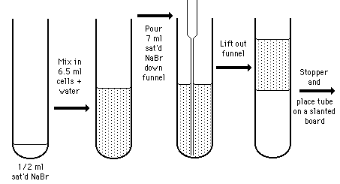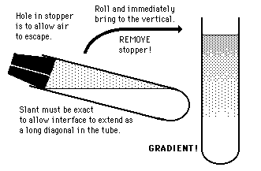
The beauty of this procedure, which was invented by this author with the help of a remarkable undergraduate, is that it is not limited to centrifuge tubes. Cylinders of any size will work.

  - Isopycnography (Equilibrium Density Gradient Centrifugation), which is used for separating things on the basis of differing intrinsic densities. This is a "static" system as the experimental objects come to rest at points in the tube at which they are in density equilibrium with the surrounding solvent at that point.
  - Sedimentation Centrifugation, which is used to separate things on the basis of their differing "effective" sizes, or, roughly, on the basis of molecular weights. This is a "dynamic" situation because the experimental objects have started at the top and are settling through the gradient at rates roughly proportionate to the square roots of their molecular weights.

In all instances, a centrifuge tube is filled with an aqueous solution that gradually increases in concentration of solute with depth. Depending on which of the two above uses is desired, different solutes are used.
    - In isopycnography the solvent at the bottom of the tube must have a density greater than any of the experimental objects in the tube. Some favorite solutes are the various salts of expensive cesium (caesium) such as CsCl, Cs₂SO₄, or CsFormate, and sodium bromide (NaBr). Commonly employed gradients go from specfic gravities of 1.1 (top) to 1.8 (bottom). The centrifuges are usually run at speeds of over 30,000 rpm for days so that nucleic acids or proteins can migrate to their isopycnotic points where they then float at equilibrium. A great deal of the early work in molecular biology employed isopycnography until the discovery by Agnar Nygaard (visiting prof at the Univ. of Illinois from the University of Oslo) that nitrocellulose tightly bound many of the molecules.
    - In sedimentation centrifugation, the solute is sucrose or some other not very dense substance that has appreciable viscosity. The experimental substances (usually particles) are overlayered atop the gradient, which is then centrifuged for up to 20 hours at about 20,000 rpm. It may be helpful to imagine this as Galileo's dropping the piece of lead shot and the lead cannon ball from the top of the Tower of Pisa through - not air - but molasses. The big cannon ball would hit the ground long before the bit of shot. In essence this is a matter of drag, which depends on the surface to mass ratio - the higher the ratio, the slower the descent. Thus, for example, the smaller part of a ribosome sinks much slower than the larger portion.
For items that differ only in size and have the same density, Svedberg determined that the settling rate, S, had this relationship to molecular weight.
S²/s² = MW/mw
Thus looking at the two major components of prokaryotic ribosomes, which are denominated as 16S and 23S, where "S" is the Svedberg unit, and can be thought of mnemonically as Settling or Sedimenting rates:
23²/16² = MW/mw = 529/256 = approx. 2
Thus the larger portion is about twice the size of the smaller portion in prokaryotic ribosomal subunits.
Shape plays a significant role also: imagine two sheets of paper. One is wadded into a tight ball and the other remains a flat sheet. Both are dropped from a high elevation. Which reaches the ground first? Both are the same in every way except for shape, which impinges on the relative effective surface area.
WARNING! Again! This is a system in which ALL the experimental particles in the tube will eventually go to the bottom of the tube if the tube is centrifuged too long. (In isopycnography, on the other hand, which is an "equilibrium" system, one theoretically cannot centrifuge for too long.)
The Centrifuge
The easiest and most widely used method for separating molecules is centrifugation. A centrifuge separates organelles or molecules into separate groups. A centrifuge is fairly simplistic in construction, consisting of a rotor that is spun at high speeds by an electric motor. The tubes with solutions that need to be centrifuged are held by the rotor, which spins them at a high radial velocity. Sometimes the centrifugal forces by the instrument can reach as high as 500,000 times the force of gravity.
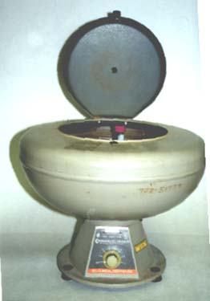
Example of a simple centrifuge
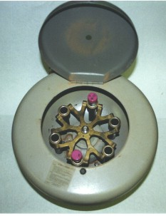
The centrifuge works if a structure is denser or has a greater mass than its surroundings, because that causes it to move downward in the tube. If it has a lesser mass or is less dense, the structure separates to the top of the test tube. There are several speeds of centrifugation, and each have a specific purpose:
- Low-speed: large, dense bodies or leftover debris from the preparation of a substance
- Higher speed: intermediate sized objects such as chloroplasts and mitochondria
- Very high speed: microtubules, microfilaments, ribosomes, etc.
For extremely precise centrifugation, two different methods are used:
- Density gradient centrifugation
- Buoyant density centrifugation
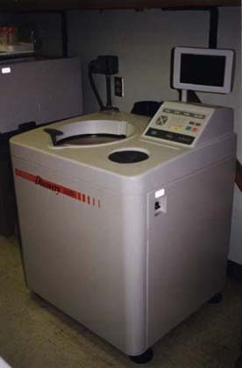
Density Gradient Centrifugation
Density gradient centrifugation is a much more precise form of centrifugation. In Density gradient centrifugation, a centrifuge tube is filled with a CsCl (cesium chloride) or sucrose solution. The solution is at different concentrations, denser towards the bottom. This is adjusted for the experiment so that the most dense concentration region at the bottom of the tube is less dense than the molecules you want to separate. The gradients separate into bands of different molecules, which remain separated because there is a distinctive higher and lower concentration level separating it and keeping it from migrating. After it is separated, a hole is punched in the bottom of the tube, and as the layers drain off, they are collected in separate fractions.
Buoyant Density Centrifugation
As the name suggests, buoyant density centrifugation uses the concept of a buoyant force to separate the molecules. Usually a cesium chloride solution is used, but in this case it's usually approximately the same density as the molecules that you wish to centrifuge. The sample is put on top of the solution, and then the tube is spun at a very high speed for a long period of time, sometimes even days. Gradually, the cesium chloride molecules are densely packed towards the bottom, so there exists even layers of different densities, and since the original solution was approximately the same density, they go to a level where their density and the CsCl density are the same, to which they form a sharp distinctive band. This method very sharply separates molecules, and is so sharp that it can even separate different molecular isotopes from one another.

